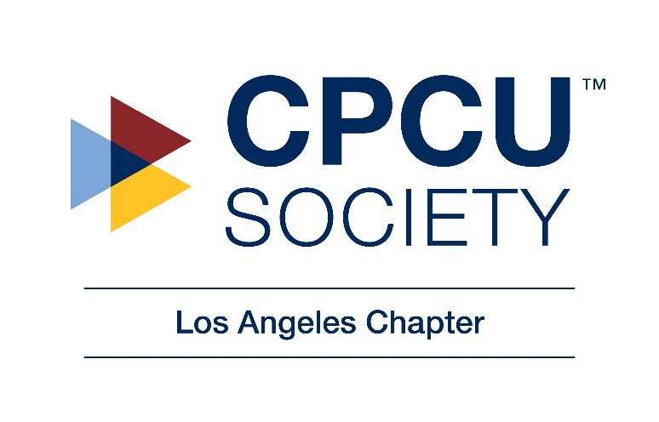
CPCU Society Los Angeles Chapter
2018 Mid-Year Planning Meeting Minutes
July 12, 2018
Location: 633 W. Fifth Street, Los Angeles, CA 90071 – Marsh Offices
12:00 Noon – 4:00 PM

Attendees: Niels Espinoza, Clark Sheffield, Kate Fuchs, Jeff Garrick, Tessa Lucero, Patricia Dillon, Paul Cunningham, Cedric Nellum, Regina Corson, Therese Barkate, George Wallace (missing: Wes Kwon)

- Board Meeting Minutes: 5/8/2018 and 6/12/2018
Niels likes Tessa’s notes from May. Moved to accept. All “Aye”. June minutes will be reviewed during next meeting in October 2018.
- Committee Matters
Cedric – good meetings with executives, most recently with Chubb. El Camino. (El Camino is our sister chapter. We do all industry day with them)
Niels will forward invite for casino night
  - Volunteer Recruitment and Development
  - New Designees
Regina: 17 new designees in 2018. 6 from DOI. Information comes from website. And we get chapter reports.
  - Education
Tessa – on hiatus this summer. CPCU books have been revised in the past 2 years. Tessa outlined classes that will be offered in Fall. Niels asked about classes at Santa Barbara.
  - Good Works/Events
Kate – collection for school supplies (see website schoolonwheels.com). Bottles of wine and gift cards ($5 or $10) for raffle. August 2nd date. Cost is $53/person. $1,500 in our budget to donate per Therese. (School on Wheels in August will get check. Midnight Mission in October $500 each) Kate proposed motion to accept. All “aye” Niels has been getting follow up emails from Midnight Mission for us to do lunch or dinner service.
  - Membership
Paul – did analysis of June report to determine retention. Will send list of unpaid to Board to find out if there are people we know who should have paid to follow up.
  - Publicity
Jeff – discussed bringing on webmaster at last meeting. She has been taking photos (Stephanie Chang has completed 4 courses) Regina works with her. She can join Board on honorary basis, but can’t vote. Jeff will reach out and get her up to speed
  - Social Media/Website
  - Finance
  - Planning 2018
Jeff – send RSVPs to August 2nd event Karl Strauss. He will not be able to attend. Niels signed contract on May 18th
Kate – hold events at Public School on Flower St?
Jeff – October luncheon – bring in property engineer. Swiss Re guy and another person? Broker side, maybe?
Kate – December holiday party – 2nd Thursday in December?

- 2018 Budget Discussion, to include
  - Current Financial Report
Theresa – currently in the black. Will move into red>96% of membership dues have been paid. One more meeting in 2018 at Johnathan Club. Lost a lot of $ on Dodgers game. $158 for wine in June. Has $200 in petty cash. Can she put in bank? Yes. We are getting .03% return on our money market account. Current bank was selected because it was in the same building. Tessa – credit union might give better rate. Paul – bigger bank has mobile deposit which is great for IDay. Theresa will check rates and let us know. If we move, would be both money market and checking.
  - Income and Expenses
  - Miscellaneous budget discussion
  - Meeting Sponsorships/Chapter Sponsorship
- 2018 Officers and Board
  - Returning Members, Positions
Niels – is anyone feeling like they’ll not be part of 2019 Board? Kate has to work on Iday. Wants to stay involved, but maybe not on board. George on the fence.
  - Recruitment of New Members
Niels – we need more. The challenge is that employers are not supporting (paying) for membership.
- Annual Meeting: October 13-16
  - Attendees
Who’s going? We have $8,000 in budget. Allocate $3,000 for fixed cost. Stephanie, and ???. Pay for 5 peoples’ hotel expense.
Full registration $1,062. Discuss later
  - New Designee reception in Orlando
- Upcoming Chapter events
  - Joint New Designee Event – August 2
  - Joint Event with CAIP – September 13
  - Luncheon and Business Meeting – October 9
  - All Industry Day – November 6
    - Confirm CSUN Scholarship participation?
Tessa – if we get a request, will present to board. $500 only covers books.
  - Annual Planning Meeting and Installation – December 13th at 1 PM
- Circle of Excellence:
Niels – there is platinum level. We missed due to recruitment of new designees. Ran through handout. Tessa will talk to Linda Torres. Regina to Daveen. Need Aon folks also. Dinged on succession planning.
  - Begin draft for Jeff’s completion
    - 6 Chapter Meetings
    - Chapter Dodgers Game
    - Joint ND event with El Camino – pending
    - Joint event with CAIP – pending
    - ND event at Annual Meeting (So. CA & HI) – pending
    - I-Day – November 6, 2018
    - Need one or two Good Works
    - Membership retention rate for 2017 NDs by 8/31/18
Goal 50%: Current only 2 of 11 have paid 2018 Dues
Paul ran through names of those who have not paid
- Additional/New Business
2019 meeting venues. We need sponsor for Johnathon Club – Owen Haggerty? Gallagher has membership at CA Club. Is this a viable option? Budget = 40/person. Johnathon club charges $300 room rent, $42 food, $10 beverage. Regina – does it always have to be a luncheon? Could we do late afternoon followed by happy hour? Tessa – could meet at Marsh office; however, reception would need names of all attendees.
Jeff - suggested tour of new football stadium under construction in Inglewood in 2019

